ASSINGMENT – 2.4
NAME : BERELLI PRIYANKA
HALL TICKET NO : 2303A52468
BATCH NO : 42
Task 1: Book Class Generation
Prompt : Generate a Python class named Book for a simple library management system.
CODE :
Generate a Python class named Book for a simple library management system.
class Book:
def __init__(self, title, author, isbn):
self.title = title
self.author = author
self.isbn = isbn
self.is_available = True

def borrow_book(self):
if self.is_available:
self.is_available = False
return f"You have borrowed '{self.title}' by {self.author}."
else:
return f"Sorry, '{self.title}' is currently unavailable."

def return_book(self):
if not self.is_available:
self.is_available = True
return f"You have returned '{self.title}'. Thank you!"
else:
return f"'{self.title}' was not borrowed."
def __str__(self):
availability = "Available" if self.is_available else "Unavailable"
return f"Title: {self.title}, Author: {self.author}, ISBN: {self.isbn}, Status: {availability}"
# Example usage:
if __name__ == "__main__":
book1 = Book("The Great Gatsby", "F. Scott Fitzgerald", "978-0743273565")
print(book1)
print(book1.borrow_book())
print(book1)
print(book1.return_book())
print(book1)
print(book1.borrow_book())
print(book1.borrow_book())
print(book1.return_book())
print(book1.return_book())
print(book1)

OUTPUT :
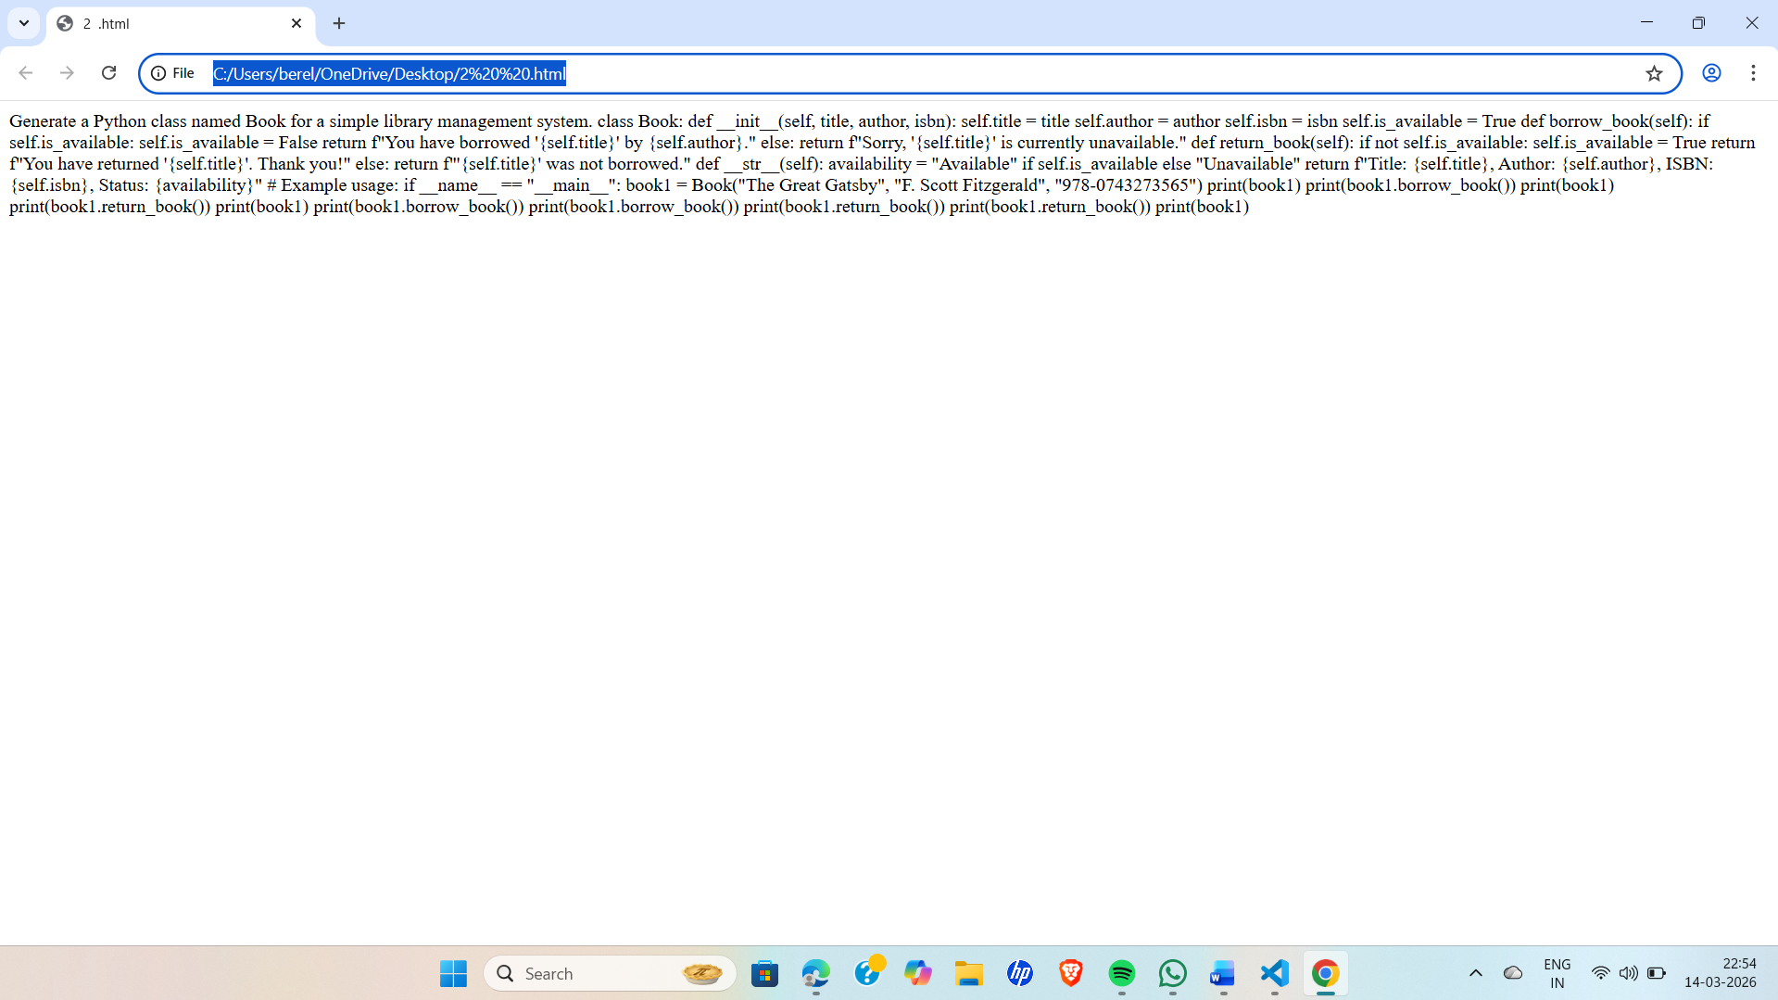
LINK : file:///C:/Users/berel/OneDrive/Desktop/2%20%20.html
EXPLAINATION : This task uses Cursor AI to generate a Book class in Python with attributes title and author, and a summary() method.
The goal is to practice AI-based code generation and review the clarity and quality of the generated code.

Task 2: Sorting Dictionaries with AI
Prompt : Generate a Python program that sorts a list of dictionaries by the key "age".
CODE :
Generate a Python program that sorts a list of dictionaries by the key "age".
# Sample list of dictionaries
people = [
{"name": "Alice", "age": 30},
{"name": "Bob", "age": 25},
{"name": "Charlie", "age": 35},
{"name": "David", "age": 20}
]
# Sorting the list of dictionaries by the key "age"
sorted_people = sorted(people, key=lambda x: x["age"])
# Printing the sorted list
for person in sorted_people:
print(f"Name: {person['name']}, Age: {person['age']}")

OUTPUT :
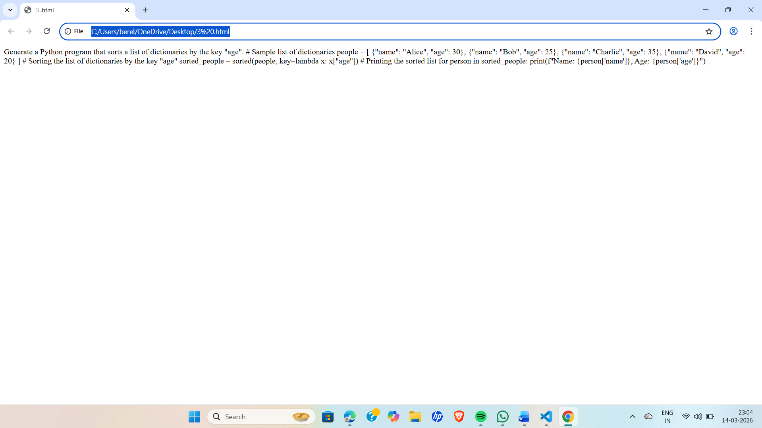

LINK : file:///C:/Users/berel/OneDrive/Desktop/3%20.html

EXPLAINATION : In this task, Google Gemini and Cursor AI are used to generate a Python program that sorts a list of dictionaries based on the age key.
The goal is to compare both AI outputs to see which code is clearer, easier to understand, and more efficient.

Task 3: Calculator Using Functions
Prompt : Generate a simple calculator program in Python using functions.

CODE :
Generate a simple calculator program in Python using functions.
def add(a, b):
return a + b
def subtract(a, b):
return a - b
def multiply(a, b):
return a * b
def divide(a, b):
if b != 0:
return a / b
else:
return "Error: Division by zero is not allowed."
# Example usage:
if __name__ == "__main__":
num1 = float(input("Enter the first number: "))
num2 = float(input("Enter the second number: "))
operation = input("Choose an operation (add, subtract, multiply, divide): ").strip().lower()

if operation == "add":
result = add(num1, num2)
print(f"The result of adding {num1} and {num2} is: {result}")
elif operation == "subtract":
result = subtract(num1, num2)
print(f"The result of subtracting {num2} from {num1} is: {result}")
elif operation == "multiply":
result = multiply(num1, num2)
print(f"The result of multiplying {num1} and {num2} is: {result}")
elif operation == "divide":
result = divide(num1, num2)
print(f"The result of dividing {num1} by {num2} is: {result}")
else:
print("Invalid operation. Please choose from add, subtract, multiply, or divide.")

OUTPUT :
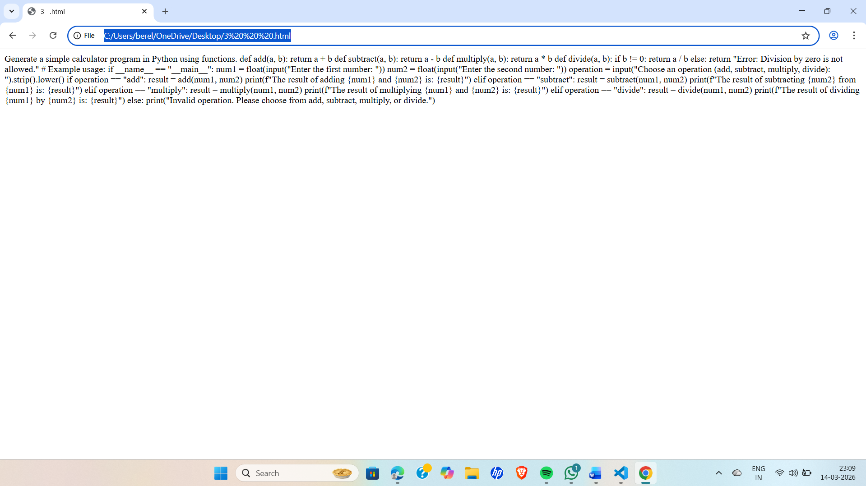

LINK : file:///C:/Users/berel/OneDrive/Desktop/3%20%20%20.html

EXPLAINATION : In this task, Google Gemini is used to generate a calculator program using functions in Python.The program includes functions for operations like addition, subtraction, multiplication, and division. The goal is to understand how functions organize code and make programs easier to reuse and manage.

Task 4: Armstrong Number Optimization
Prompt : Generate a Python program to check whether a number is an Armstrong number.
CODE:
Generate a Python program to check whether a number is an Armstrong number.
def is_armstrong_number(num):
# Convert the number to a string to iterate through its digits
num_str = str(num)
num_digits = len(num_str)

# Calculate the sum of the digits raised to the power of the number of digits
armstrong_sum = sum(int(digit) ** num_digits for digit in num_str)

# Check if the calculated sum is equal to the original number
return armstrong_sum == num
# Example usage:
if __name__ == "__main__":
number = int(input("Enter a number to check if it is an Armstrong number: "))
if is_armstrong_number(number):
print(f"{number} is an Armstrong number.")
else:
print(f"{number} is not an Armstrong number.")

OUTPUT :
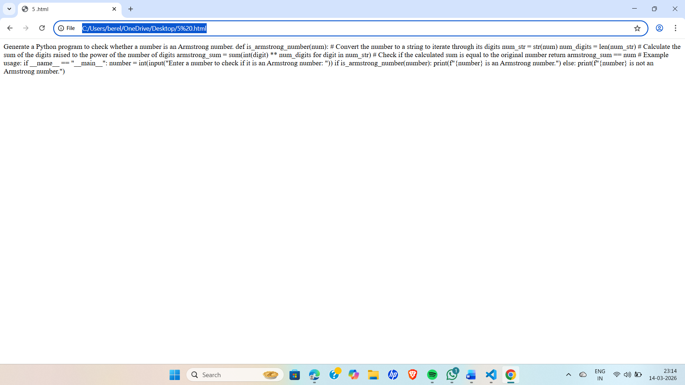

LINK : file:///C:/Users/berel/OneDrive/Desktop/5%20.html

EXPLAINATION : In this task, Google Gemini first generates a basic Python program to check whether a number is an Armstrong Number.
Then Cursor AI is used to improve the program by making the code more efficient, readable, and better structured.

